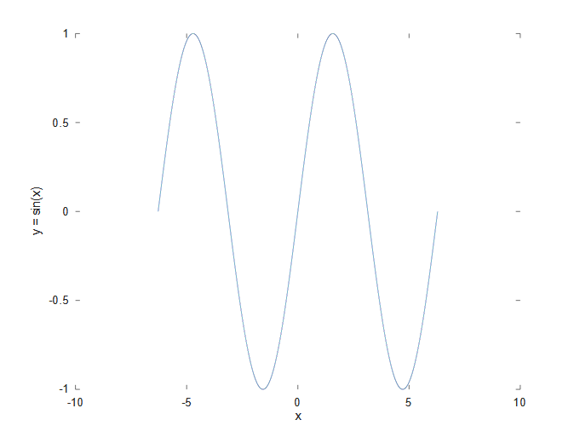
Assignment 4
Plotting y = sin(x) Graph

Code:-
class all
x=-2*pi:0.0001:2*pi;
y=sin(x);
plot(x,y,'-');
xlabel("x");
ylabel("y = sin(x)");

Graph:-

